## **Polynomial Regression**

Polynomial Regression is a form of **linear regression** where the relationship between the **independent variable** x and the **dependent variable** y is modeled as an n-degree polynomial.

It is used when data shows a **non-linear** relationship that a straight line (simple linear regression) cannot fit well.

### **Mathematical Representation**

A **degree-n polynomial regression** is:

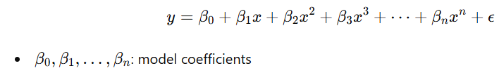

Although the equation is nonlinear in terms of x, it is **linear in parameters** βi​, hence it is still considered a linear model.

### **🔹 Why Use Polynomial Regression?**

* To capture **curved trends** in the data.
* Useful when plotting residuals of linear regression shows **non-random patterns**.
* Helps model **complex relationships** with more flexibility.

### **🔹 Visual Intuition**

| **Degree** | **Fit Shape** | **Use Case** |
| --- | --- | --- |
| 1 | Line | Linear relationship |
| 2 | Parabola | Single curve (e.g., U-shape trends) |
| 3 | S-curve | More complex patterns |
| 4+ | Wiggles/Waves | Even more complexity, but beware overfitting |

### **Choosing the Right Degree**

* **Too low** → underfitting (high bias)
* **Too high** → overfitting (high variance)

Use techniques like:

* **Cross-validation**
* **Plotting learning curves**
* **Regularization (Ridge/Lasso with polynomial features)**

### **🔹 Advantages**

✅ Captures non-linear relationships  
 ✅ Easy to implement  
 ✅ Flexible model behavior

### **🔹 Disadvantages**

❌ Sensitive to outliers  
 ❌ Can overfit with high degree  
 ❌ Model interpretability decreases with degree

### **🔹 Real-world Applications**

* Predicting population growth
* Modeling economic trends
* Fitting curves in physics/engineering experiments

### **🔹 Summary**

| **Concept** | **Description** |
| --- | --- |
| Type | Supervised, Regression |
| Model Shape | Polynomial curve |
| Use case | When data shows non-linear patterns |
| Key Concern | Overfitting with high-degree polynomials |